**PHP: Basics of MySQL & Mongo**

**MySQL:**

**1. Fetch employee's Name, address, Phone, Dob, Department, salary whose salary is greater than the average salary.**

**ANSWER 1:**

**Table :**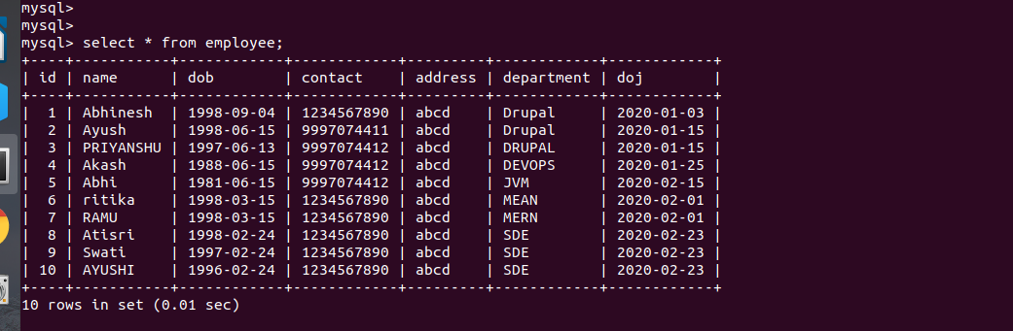

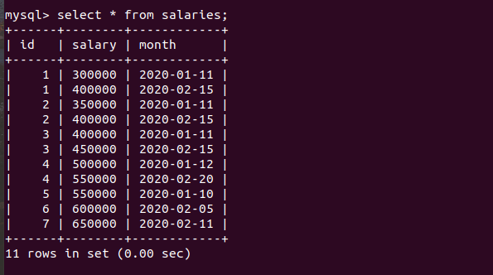

**COMMAND:select** employee.name,employee.dob,employee.contact,employee.address,employee.department,salaries.salary from employee INNER JOIN salaries ON employee.id=salaries.id AND salaries.salary>(select avg(salary)from salaries);

**SCREENSHOT:**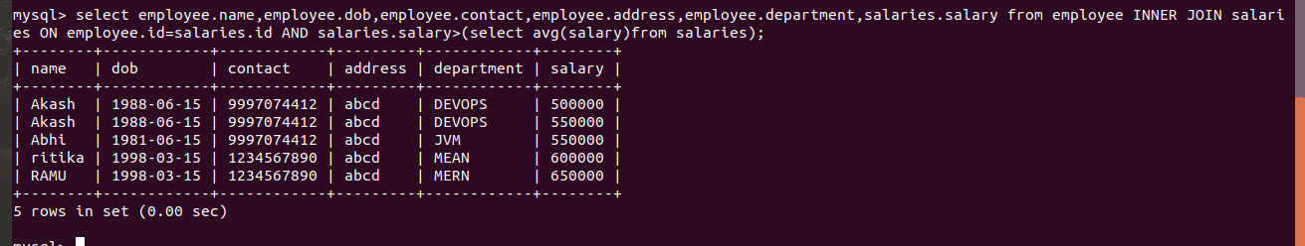

**output:2. Fetch Paid average salary for the current month.**

**ANSWER 2:**

**COMMAND:**select avg(salary)from salaries where MONTH(month)=MONTH(NOW());

**output:**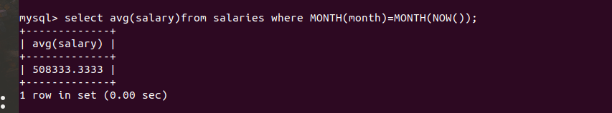

**3. Fetch the top 5 Employee's Name, Phone, Salary month, Paid salary for the current month**

**ANSWER 3:**

**COMMAND:**  select employee.name,employee.contact,salaries.month,salaries.salary from employee INNER JOIN salaries ON employee.id=salaries.id AND MONTH(salaries.month)=MONTH(NOW())order by salaries.salary desc limit 0,5;

**output:**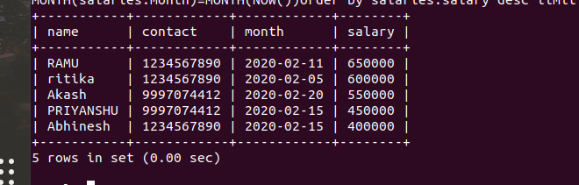

**4. Fetch the employee's name, phone, dob, department name, salary who join last month.**

**ANSWER 4:**

**COMMAND:**select e.name,e.contact,e.dob,e.department,s.salary from employee e INNER JOIN salaries s on e.id=s.id AND e.id in (select distinct (id)from salaries)AND MONTH(e.doj)=MONTH(NOW())-1 AND MONTH(s.month)=MONTH(NOW());

**OUTPUT:**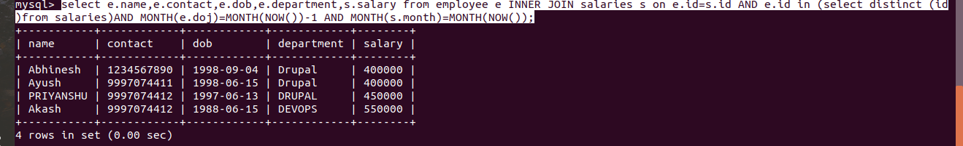

**5. Create a Program in PHP that will fetch and show employee details whose DOB is today?**

**ANSWER 5:**

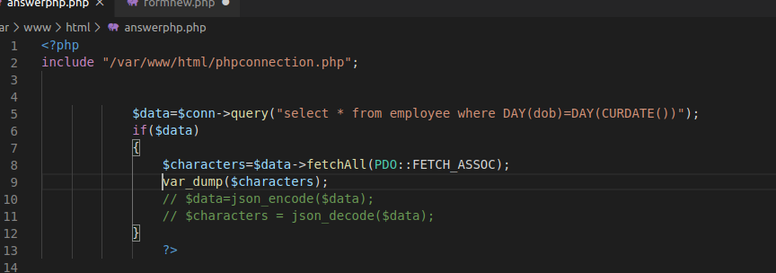

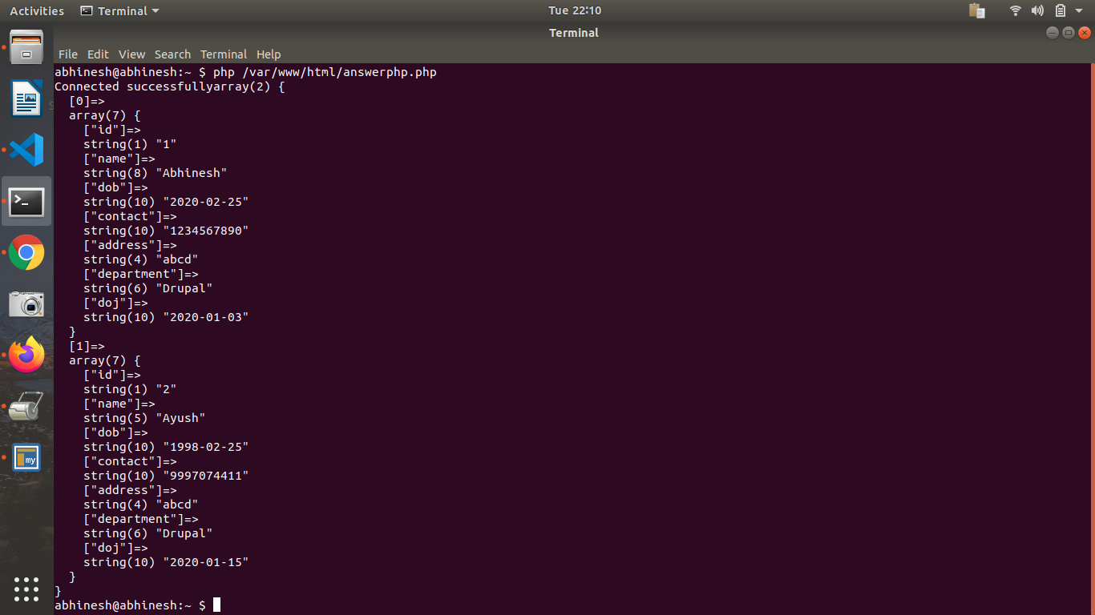

**7. What are the advantage & disadvantage of Index?**

**ANSWER 7:**

**8. Create two tables in MYSQL that shows working of INNER, LEFT, RIGHT.**

**ANSWER 8:**

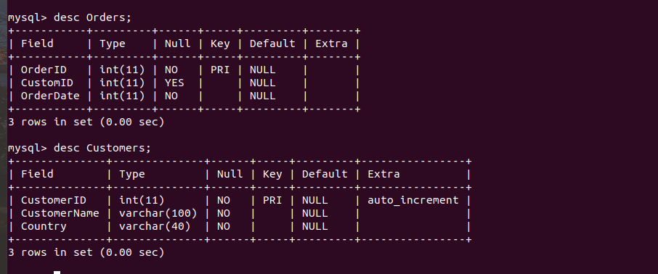

**LEFT JOIN**:SELECT Orders.OrderID, Customers.CustomerName, Orders.OrderDate FROM Orders LEFT JOIN Customers ON Orders.CustomID=Customers.CustomerID;

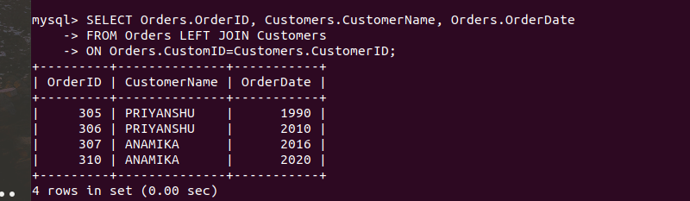

**RIGHT JOIN:** SELECT Orders.OrderID, Customers.CustomerName, Orders.OrderDate FROM Orders RIGHT JOIN Customers ON Orders.CustomID=Customers.CustomerID**;**

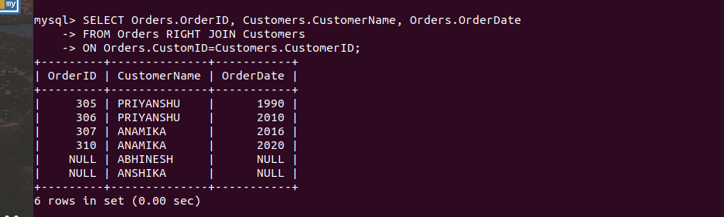

**INNER JOIN:**SELECT Orders.OrderID, Customers.CustomerName, Orders.OrderDate FROM Orders JOIN Customers ON Orders.CustomID=Customers.CustomerID;

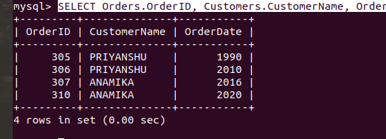

**MONGO:**

**9. create a database "Bootcamp" with table "mongo".**

**ANSWER 9:**

**10. Write a PHP program to perform Create, Read, Update and Delete Operations.**

**ANSWER 10:**

**CONNECTION:**

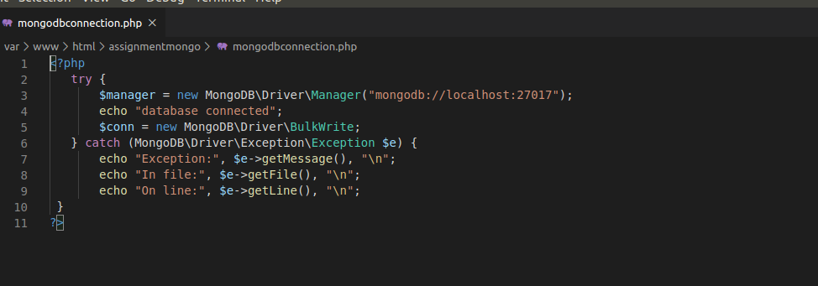

**COLLECTION TABLE:**



**INSERT DATA :**

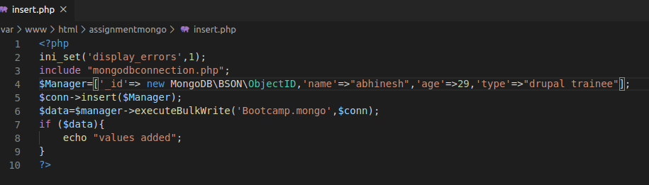



**UPDATE DATA:**

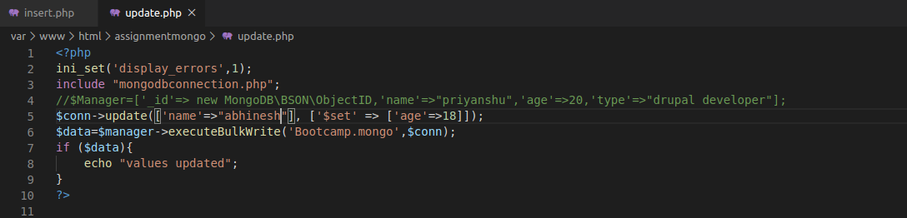



**DELETE DATA:**



